H.T No
Regulations:
A15


Sreenidhi Institute of Science and Technology
(An Autonomous Institution)
Code No: 5K502 Date: 30-May-2019 (AN)

B.Tech III-Year I-Semester External Examination, May/June-2019 (Supplementary)
Structural Analysis - II (CIVIL)

Time: 3 Hours Max.Marks:75

Note: a) No additional answer sheets will be provided.
b) All sub-parts of a question must be answered at one place only, otherwise it will not be valued.
c) Missing data can be assumed suitably.

Part - A Max.Marks:25

Answer all QUESTIONS.

1. | A UD live load of 60KN/m run of length 5m moves on a girder of span 16m, find maximum positive and negative shear force at a section 6m from the left end. | [3M]
2. | Derive an expression for effect of shortening of rib in a two hinged parabolic arch. | [3M]
3. | Write a short note on temperature stresses in two-hinged girder. | [3M]
4. | Develop flexibility matrix for the beam AB shown in fig. EI is constant throughout.  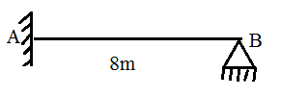 | [3M]
5. | Define stiffness matrix. | [3M]
6. | State assumptions in plastic theory. | [2M]
7. | Name the type of rolling loads for which the absolute maximum bending moment occurs at the mid span of a beam. | [2M]
8. | Define plastic hinge. | [2M]
9. | A simply supported beam of rectangular section carries a uniformly distributed load over the whole span. Determine at collapse condition, what part of the beam is fully elastic. | [2M]
10. | Determine the horizontal thrust developed in the semi-circular arch of radius 18m. loaded as shown in fig.  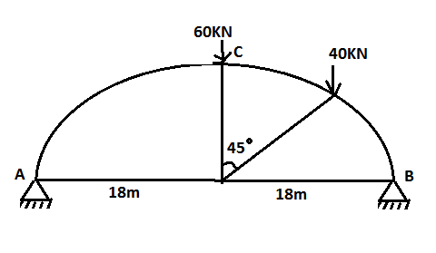 | [2M]
Part – B Max.Marks:50
ANSWER ANY FIVE QUESTIONS. EACH QUESTION CARRIES 10 MARKS.

11. |  | Five wheel loads 10KN, 20KN, 15KN, 30KN and 18KN spaced at 0.8m interval roll on a girder of span 25m from left to right with the 10KN load leading. Find  - Absolute maximum bending moment for girder.  - Greatest reaction at A  - Bending moment at a section 10m from left support. | [10M]
12. |  | A two hinged semi-circular arch of span 20m is subjected to uniformly distributed load of 50KN/m over the whole span and a concentrated load of 80KN at 5m from right support. Determine the horizontal thrust. | [10M]
13. |  | A cable of span 20m and dip 4m carries a uniformly distributed load of 20KN/m over the whole span. Find  - Maximum tension in the cable.  - Minimum tension in the cable  - The length of the cable. | [10M]
14. |  | Analyze the frame shown in fig. by force method. Draw bending moment diagram.  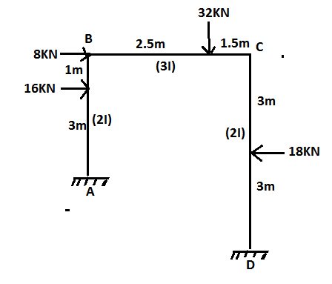 | [10M]
15. |  | Analyze the frame shown in fig. by displacement method.  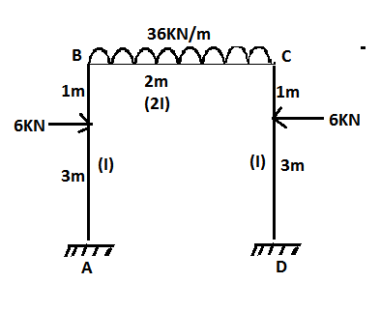 | [10M]
16. |  | Find the plastic moment of resistance required for a propped cantilever of span 5m to carry a safe concentrated load of 50KN at a distance of 3m from the fixed end. Take load factor=1.7. | [10M]
17. |  | Determine the influence line ordinates at 1m interval for moment at mid- span of BC of the continuous beam shown in fig.  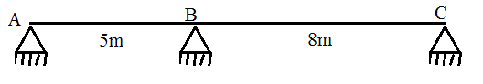 | [10M]
18. | a) | Write a brief note on pushover analysis. | [4M]
 | b) | Find the shape factor for a beam of circular section of radius R. | [3M]
 | c) | Find the shape factor of a thin hollow circular cross-section. | [3M]

-- 00 -- 00 –

